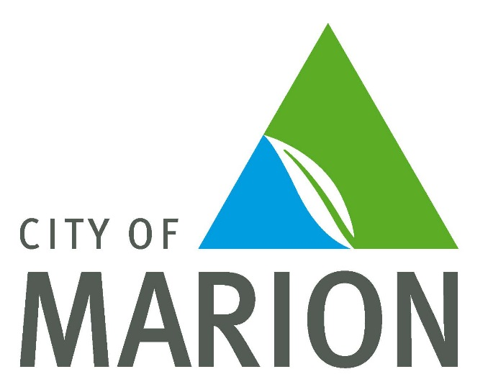

Jervois Street Reserve Evaluation
Community Feedback Report

March 2017

Jervois Street Reserve Evaluation
Community Engagement Summary
March 2017

Following the recent development of Jervois Street Reserve, we recently sought the community’s feedback about the development.

We asked the community what they thought about their new playground, and what they would like their reserves and playgrounds to look like in the future.

This survey was made available on-line at makingmarion.com.au/jervois-street-reserve.

The survey link was distributed in the following ways
- A postcard advertising the link was mailed to 1212 households
- Social media posts were placed on the City of Marion Facebook page
- A sign was placed at the reserve
- A parks and playgrounds newsletter was sent to a database of 432

The survey was open for 3 weeks – 30th January 2017 - 20th February 2017

We had a total of 93 people complete the survey.
A full summary of all responses to each question is provided as Attachment 1 to this report
Feedback is overwhelmingly positive with considerable constructive feedback received.
Overall summary of key themes received
- 84 % of survey respondents agreed or strongly agreed that the development has helped build connections amongst the local community.
- 63% respondents live more than 500m from the reserve and drive their car. It is interesting to note that many respondents commented that they drive from other suburbs to play.
- The main attraction for the reserve, with 62 preferences for the junior playspace and 52 respondents indicated that the age of the children using the reserve is 0- 3 years. However, the other spaces in the reserve attracted positive comments and are also well utilised.
- Reserve usage is high with nearly 55% of respondents using the reserve once a week, twice a week or fortnightly.
- Many visitors (39%) spend 1 ½ to 2 hours at the reserve.
- 72% of respondents are happy with the amenities provided at the reserve, but would like more shade.
- A second toilet is a priority for many respondents.

Attachment 1 – Summary of feedback received
Q1. Do you feel the reserve upgrade has helped build connections among the local community? This may have been experienced through more residents seeing each other at the reserve, having an opportunity to greet each other and share the space.

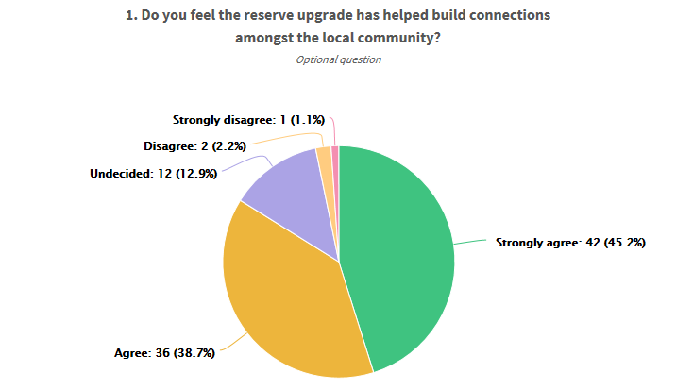

Comments included:
- Every day there is people from different backgrounds all enjoying the park
- I love being able to go to the park and interact with cultures family & friends
- It's probably the most well planned play space I've ever been too
- We use the reserve as a meeting spot for the mums group I am involved with.
- People go to this park from near and far.
- Don't live in the area but visited once ... lots of families there on a weekday.
- Allows locals to interact while enjoying the park
- "Kids love to work together in the creek bed, pumping the water and collecting it.
- Great place for dogs to meet also."
- There are limited attractions or reasons to visit the reserve for my age group.
- I went shortly after the opening and haven't been back since. The reserve seems very crowded especially at weekends with lots of people in organised party groups it would appear. As a local you would have to be very early to get a spot. The reserve parking on both sides of Jervois St has restricted traffic to single lane I think a fence should be erected to avoid the possibility of a toddler straying onto the street. I envisaged the reserve being somewhere to go and relax not a children's playground. Apart from that it is pleasing to the eye.
- "I have lived in Edwardstown for 30 years and raised my children here. Taking them to local parks. Often the only people there.
- I have never seen so many people of all ages using a park.
- You have created a space people want to use.
- It makes my husband and I smile each time we drive past and see people enjoying the space
- Thank you "
- Having just moved to Adelaide I have no connection with the local community around the park.
- It's nice meeting other mothers and cares.
- Every time we have been there people are commenting on what a great space it is and how well done everything is. We have arranged to meet other families there and I have overheard many others saying that its a great place to meet and let the kids have some fun.
- You have created a toddler/preschool playground and it is this group that connect there.
- Great to see so many families out enjoying the playground, we probably wouldn't see them otherwise
- I have chatted to people at the park and I have seen crowds of people meeting at the park.
- Lots of parents with children meeting up, while children play. Have spoken to quite a few folk with children enroute to the reserve.
- In the first week of opening, I couldn't believe how many people attended the park - there was a palpable feeling of community and given that most of the time we hear about crime, assaults and bad news, it was an absolute joy to see so many people, from so many backgrounds, coming together to enjoy the park! Well done Marion Council!!!!
- Yes I have met mums dads aunts and grandparents at this play facility
- I am a resident and mostly I meet people from other suburbs.

Q2. Approximately how far do you live from the reserve?

0 – 100m | 3
100 – 200m | 9
200 – 300m | 10
300 – 500m | 13
500 – 1000m | 21
>1000m | 37

Q3. How do you get to the reserve?

Walk | 51
Ride a bike | 10
Car | 48
Other | 1

Comments for other included:
- Me & the dog
- Walk from work
- Car when taking my nephew, walking when exercising
- I don't go

Q4. What is the main attraction for you to visit this new reserve?

Junior Playspace | 62
Pump Track (BMX) | 24
Sports Court | 15
Playspace | 37
Fitness Equipment | 8
BBQ and shelter | 17
Other | 17

Comments included:
- The dog loves it
- Open space & interaction with others
- swings, slide, drums and plenty of grass to run around
- Bike/running track around the edge has been popular with the two boys to cycle/scoot around.
- Grassed area for babies to lay on o rugs
- fully fenced in toddler area with a range of activities
- A pleasant space to walk to and sit and rest before heading home again. Great playspace for my young nephews
- My kids love the WHOLE space and use it all
- Bike track
- Natural elements incorporated into play equipment. It doesn't feel overly sanitized and plastic
- only the walking track as the fitness equipment is not suitable for over 50 year olds (unless they are super fit). more suitable equipment such as at Goodwood train station - exercise bike, bicep press, quad press, etc
- I don't go
- Basketball court is amazing. Love using it every time. Although, it would be highly great and affordable with a chain net, as it lasts longer and also saves money.
- Toilet
- Running my dog around it and enjoying seeing people using it
- I walk my dog in the area and we do a lap of the park as part of our walk (he is on a lead!)
- Love everything this space has to offer!!
- There are so many different things for the kids to do and so they aren't bored easily and we are able to stay for the whole morning
- Have taken grandchildren, ages 5 & 8 but they were quickly bored. The hanging fox(?) is set to high for them to reach.
- Simply how pleasant it is to be outside sit and have a place where people can be active, friendly and relax.
- I take my grandchildren they have enjoyed all spaces
- Walking dogs. Unable to use BBQ/ shelter as always taken over by groups for parties with someone "booking" the table area under the shelter from early morning - many from a great distance from Marion council. Locals unable to use.
- Grassy areas to walk or sit on
- We walk past it and through it on our regular walks
- Great place to walk the dog
- The seating
- Water sand area swings and grass area

Q5. What is the age of children from your household who visit the reserve?
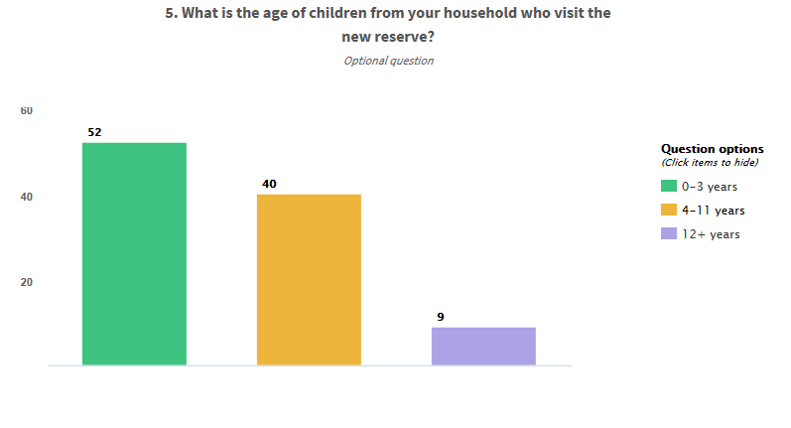

Q 6. How often do you visit the new reserve?
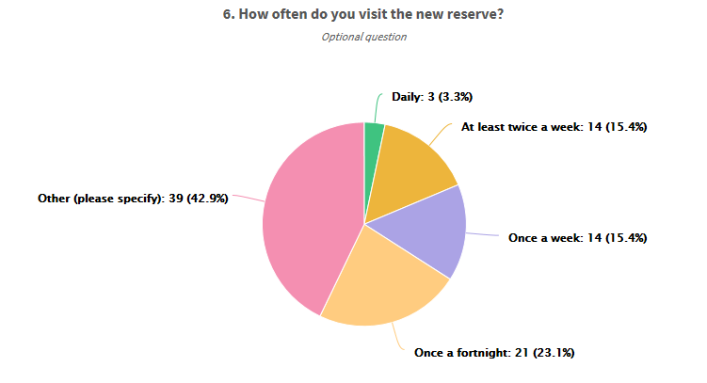

Comments received
- School holidays mainly.
- Once or twice a month
- I take children I work with there and I take friends kids and friends take their own kids after they've found out about it
- Bi monthly
- Monthly
- Once a month
- once a month
- Twice a year
- Only took my grandson once as he used to live near there and wanted to go back to play. I will not be in a hurry to return.
- Once a month. Plan to go more often in cooler weather
- About once a month as it's too far to walk there from Mitchell park with kids
- Once every 3-4 weeks
- Monthly
- Approx once a month
- Monthly
- Once a month. In holidays once a week. Often go there for kids parties
- monthly
- limited attractions to the over 50 year olds unless picnicking as part of family/friends group. if appropriate fitness equipment was erected my visits would be daily/every second day.
- Not at all
- about monthly
- Roughly 4 times a week
- I don't have any children but visit the park with my dog or children of friends
- Have only been once
- At least once a month. We are about 20km away
- Only on two occasions so far
- Monthly, maybe more.
- monthly
- Monthly
- Monthly
- Once every month
- Once or twice a month when we can. It's not close to home, but worth the drive.
- Once a month
- Visit several times after opened. No longer interested.
- Every couple of months. We used to live much closer and would have utilised the park every few days.
- Every now and then as we have to travel from Hove
- with grandchildren and I am a keen walker hence visit on walks
- First time today
- Visit with neighbour's grandson & a nephew from Melb's son
- Occasionally
- once a month
- Monthly
- Once a month

Q7. On average, how long do you spend at the new reserve?

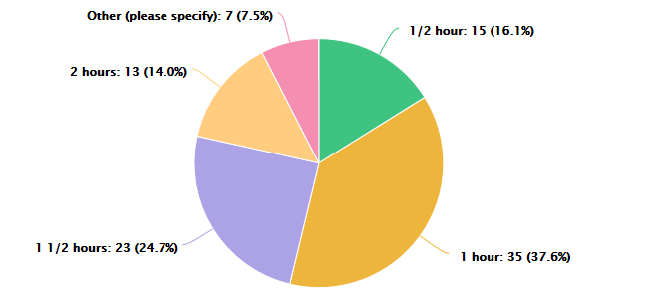
Comments received included
- 2-3 hours
- 1/2 day most times
- limited as there is nothing to attract my age group
- Nil
- 10 mins enjoying watching young families use it
- Always turn the visit into a picnic
- More than 2 hours

Q8. Is the maintenance carried out at the reserve sufficient?
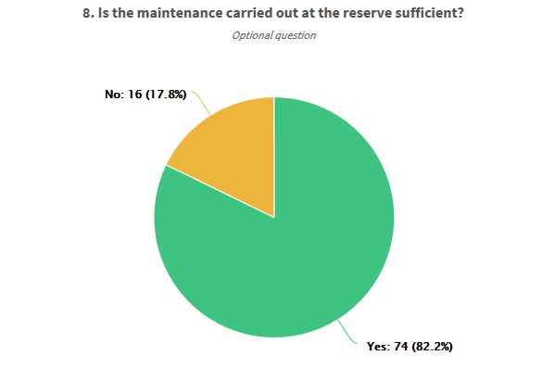

Comments Included:
- The bins near the BBQ are always used overall considering how many people use this park everything seems to be settling in
- Bins emptied on weekends
- they do a great job, cleaning up and gardening. I think the sand pit may need a top up?
- During hot weather, grass looked like it needed a good water.
- Flying fix handle broken last time we visited
- So far everything works but toilets could be cleaner.
- We are a bit worried that a child could fall of the edge walking up to slippery dip could do with atop up of sand
- The wooden worm is split and dry, as are the wooden exercise benches ... not splintery yet but look like that isn't far off. The garden beds were unkempt. Wood used seems not the most suitable for outdoors
- I don't think I've ever seen the toilets clean
- Some of the trees are dead and need to be removed.
- Some young trees have been damaged and need to be replaced and protected until they are older
- Don't know
- Rubbish overflowing, no toilet paper.
- The Bins overflow with rubbish and the toilet facilities are inadequate for the amount of people who use the park. Especially for little children who need to go urgently and cannot wait in line.
- Every morning I see the people come to clean the toilet and the park always looks great
- Haven't seen any problems on the occasions we have been.
- It needs fence.
- Rubbish in my toddler area was accumulating. Don't recall any bins in here. Disposable coffee cups etc were left.
- The lawn in the mounds needs to b roped of to get it more established. I have seen various maintenance people. Bins can sometimes be overflowing with rubbish.
- Insufficient bins, large amount of litter and food on the grounds, left by large groups having parties.
- Not sure - have collected rubbish at times from around the perimeter when walking the dog
- It's a popular reserve and needs a lot of frequent maintenance due to high use on the weekends and public holidays
- Bins are always full. It seems like visitors need to be told not to litter.

Q.9 Are the amenities provided at the reserve sufficient?

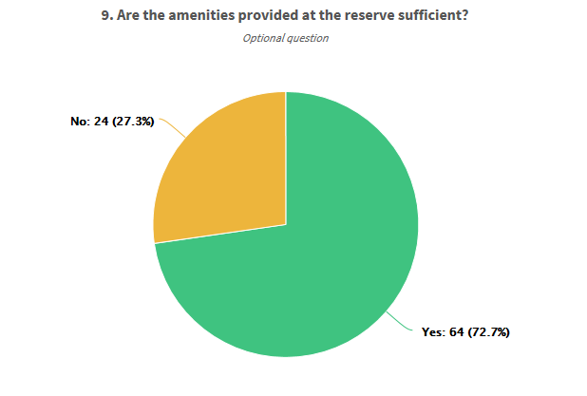
Comments Included:
- BBQ scrapers
- have seen them malfunction where they wouldn't open for over half an hour, there was no one inside.
- Shade is the current issue. It's too hot a park to visit at the moment in summer except for early mornings or cooler days. So I guess anything that can be done to speed up the growth of the trees with lots of water and dynamic lifter will speed things up. Otherwise my 2 boys love the park.
- An extra toilet would be great, as the park is often so busy and there's a long wait...very hard for my 3-year-old to hold on that long!
- "It is hard to stay there if temperature is very hot. Most of area is not yet shaded by trees.
- The Flying Fox is not easy to use .. can't reach handles in middle when they just hang there ... Not suited to young ones at all and doesn't have a landing spot on the other side .."
- Shaded areas are lacking. The trees will eventually provide this - in 5 to 10 years.
- More than one toilet
- Needs more shelter, very hot on sunny days. maybe another BBQ area? 4 birthday parties there today.
- Personally I frequent the reserves like the John Miller and Wrigley reserves for the adult exercise equipment. Very popular equipment in many metro and regional reserves. Much needed in Marion
- More seating and shade needed
- Love the chess boards and table tennis and the toilet. Something for all ages
- One toilet with young children is definitely not sufficient. I had to line up for 20 minutes two weeks ago for my 4-year-old to use the toilet. Which resulted in him soiling his pants.
- Loo gets very busy at times. I have encountered staff from local businesses who's loos were out of order using the park. They took ages which is very hard when young children need to go
- There always seems to be a queue for the toilet which is hard for little kids to wait. Also it desperately needs more shade
- Often a queue for the toilet, perhaps another would be good.
- Not sure. Haven't been there when its busy.
- More than one toilet would of been better. Esp. with children that can't wait!
- Should be larger area of seating under shade.
- BBQ's could be installed on both sides of the park as should bins
- Feel that there could be more facilities for toddlers as park seems to be more focused on older children etc
- One toilet for such a large play space is not enough.
- Everything is great, but the one thing we think it needs is more shade. We often bring a snack or lunch for our boys, and because it's normally a busy place there is very little chance of finding some shade to sit in. We found ourselves squeezing under a tiny tree on the southern end of the park to utilise a small piece of shade.
- Parks are not just for toddlers. There is a lack of shade and seating for older residents. Jervois end is much quieter, away from the children but lacks facilities. Benches and tables for picnics, catch up with friends etc would be excellent in this area. I have never seen table tennis used or any activity in the central area.
- "Needs more shelter especially over the junior area over the slide and over the benches where parents sit and watch.
- Maybe soccer goals"
- Lack of sufficient shade. No appropriate parking available. Single car passage only the length of Jervois Street from Towers to Laurence Road every weekend and all through school holidays.
- Excellent re toilet, barbecues, and shade structure (also protects from rain) on Waterhouse Rd side. However, there is inadequate shade/protection on the Jervois St side. Trees are of limited help. Some families erect their own umbrellas etc or simply avoid Jervois side- table tennis & chess tables too hot!
- Don’t know haven’t used them
- However, a little more shade areas would be good for the large grassed areas around the edges a lot of people do bring their own. But a couple would be nice
- A recycle bin would be a great addition
- Toilet sometimes not working which can be an issue with young unpredictable kids
- Pergola area and BBQ usually full with groups/parties. Have not been able to use it at all on weekends
- Come on put another toilet in, ques crazy on some days

Q.10 Have you experienced or identified any issues following the completion of the reserve?

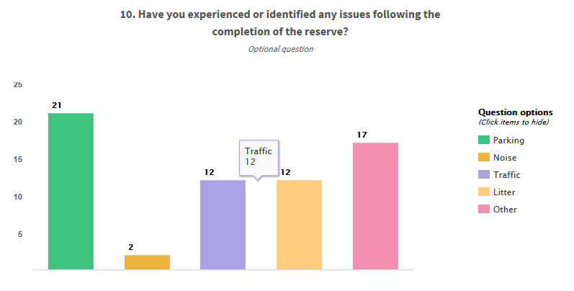

Parking Concern Comments:
- It can get really busy at times around this park
- an already busy street, there isn't enough parking, but saying that I think there should be a fence on the Jervois street side as there are always cars parked and kids can run out onto road. I feel an accident will happen before long. or you make that side of road NO parking??
- Often busy, and tight to drive on the streets
- At times it is a hazard with cars parking both sides
- it is often difficult to get a close park but the park is so popular this is expected
- Not sure on cost but Jervois St gets really hard to drive down, so maybe some of the verge could be used to indent parking spaces
- sometimes there have been parties on and required parking a long way down the road on weekends mainly
- Would of been nice to have parking slightly off the street for safety.
- There is no parking provided except on street. This blocks the road to all but one-way traffic.
- access on Waterhouse Road is congested and in some instances cars are having to give way to oncoming traffic from a significant distance. perhaps parking should be limited to one side of the road
- Dangerous on street
- There is little space to drive along Jervois Street with cars parked on both sides.
- Driving past the reserve in Jervois St can be difficult and potentially dangerous with cars parked on both sides of the street & only one car width left on the road, with children and young families crossing the street. It seems planning for parking was overlooked. There is high potential for a young child to be run over.
- At busy times, parking can be a bit far away
- To navigate Waterhouse Road or Jervois Street in front of park is horrendous. Cars are now parked around to Lawrence street. Often there will be several children's parties, etc and insufficient space. Parents are seen 'reserving' the limited shade so parking on a weekend starts early. I now take an alternative route. I have never seen anyone utilise the central space for an organised activity. People gather under shade structure or pack into toddler area. Park looks good, an excellent piece of freedom in our streets.
- "Lack of appropriate parking space. Cars parked down Jervois and Waterhouse Rds and worse on Sunday mornings with parking overflow on Towers Tce/DeLaine Ave during church service.
- "Lines of traffic in Jervois Street, hard for residents
- Lack of parking

Noise concern comments:
- Parties on the weekends and through school holidays.
- Noisy with lots of large groups parked up the street

Traffic concern comments:
- Speeding down streets
- its busy and people fly down Jervois street, maybe even making it one way for that end of the street? speed bumps?
- Jervois street is now a street to avoid, sadly I live on this street, due to the congestion caused by the park traffic reducing it to a one-way street.
- should be signage put in place for speed e.g. 25 kmph
- Jervois St is reduced to a single lane you have to pull over or sometimes reverse. Parking obviously not considered in the planning stages. More cars should be made to park on Waterhouse St.
- There is little space to drive along Jervois Street with cars parked on both sides - this needs to be a 25km zone as little children are getting in and out of cars and some cars drive too fast along this area.
- There is a lot of parked cars on either side of the reserve, in both streets. Adding to this, there are a lot of children at the park. So I hope you consider reducing the speed limit on either side of the reserve.
- So many parked cars and kids running around makes me nervous of them running onto road chasing ball or similar. Drivers won’t see them with all the parked cars
- Cars are parked on both sides of road alongside the park, which only leaves space for one lane of traffic at a time eg: one direction at a time
- Almost impossible to drive up my own street with cars parked on both sides and allowance for single car to pass in one direction.
- Unable to drive down safely with cars parked on both sides of Waterhouse and Jervois streets.
- Because cars park on both sides of the street, only one way traffic can be carried out at the time.

Litter concern comments
- there is a lot of rubbish left behind, mainly plastic toys, containers and spades used with the water and sand area and empty coffee cups. a notice for parents to take their toys with them. even providing a recycling bin for the coffee cups would be wonderful, put one near the swings. I think the BBQ area is kept pretty clean
- Bins have been overflowing each time we have visited
- Usually in the kids play area, wrappers, wipes etc.
- There are not enough bins and they are often overflowing which spreads rubbish throughout the park and surrounding streets
- Bins weren't full yet people still can't use a bin.
- There is often litter in the play areas.
- It is hard to do anything about people who deliberately walk off leaving their drink and food wrappers on the table. The overflowing bins could possibly be aided by more bins
- Not enough bins and the numbers of people having parties mean that they there is a large amount of rubbish and food left every weekend making it unsafe for dogs to be allowed off lead.
- Need more bins or more regular emptying
- Park is used a lot (which is great) but unfortunately a lot of litter is left behind at time, particularly on weekends.
- Not enough bins and large groups leaving litter
- Kids have played and moved bark, sand and stones which have ended up in other areas. Grass is a bit worn in some areas and needs repair

Other concerns:
- Nuts fallen from the A-frame support for the swings in the junior area.
- It's not completely fenced. As it's so large it's a bit stressful trying to keep numerous kids of different ages safe from going out onto the road when you're on the other side of the park with your other child
- The design of the bike track is unsafe as it takes them outside the gate.
- "The shade over the enclosed children’s play area is pretty much useless as most of the equipment is always in the sun......making it very hot and not suitable for the little ones.
- No point having a playground that can't be used in our hot summers.
- Lack of shade in other areas is an issue as well.... benches in the sun etc."
- The bike track that surrounds the park is out of sight behind the nature playground. This runs along the footpath - too close to the street. Even for 5 yo.
- No concerns what so ever.
- None that impact me
- The bike track that goes around the space can be a bit scary at times with younger children as it goes into the main path.
- A lack of shade during summer. The sandpit is good but the swings and slide could be better protected, especially considering the younger children use this area most
- "Shade!
- More shade is needed, especially since lots of the little kids accessing the playground have younger siblings/babies - it would be nice to set up picnics under shaded trees/areas. "
- Need more shaded area especially near and in toddler playground
- The fencing should enclose the entire reserve. I have twin toddlers so a fully fenced reserve is mandatory for me. I cannot take my twins there by myself as it's too dangerous.
- Once again, just that there is not enough shade on hot days.
- The dog should not be allowed in the reserve.
- Using same space for half basketball court and skateboards. Difficult when group of children are skating around while another tries to throw baskets in same area.
- The trees will take ages to grow build more sun shades!!! The butterfly one is not enough. Put some out for people to have pick nicks under or to just rest

Q.11 Would you like to see more structured activities, programs or events run from the site? Please tell us what you would like to see or enjoy?
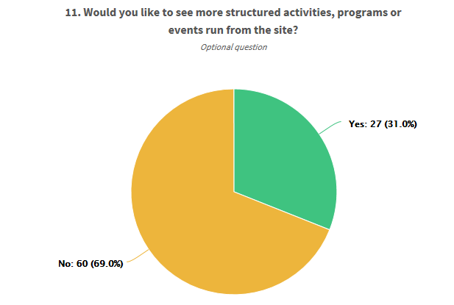

Activities include:
- outdoor cinema? nature day? yoga classes? table tennis, chess, draughts clubs?
- Organised community catch ups for children of similar ages
- "Nature Play events
- Music in Parks "
- it would be good to have an occasional event that makes use of the central oval/grass area
- Something fun for little children and their parents,
- Outdoor playgroup
- Community events
- "Coffee van on weekends and school holidays.
- Community days like the excellent opening day - we loved this."
- Nature play workshops, fitness sessions, fun day.
- Fitness classes
- kids activities run - especially during the school holidays - for kids from 2-7 years or even older.
- fitness classes; market/fair; organised family games sessions
- Events/ Programmes
- exercise classes etc and also community events, such a BBQ with a small band
- Group fitness
- Kids activities come and try days.
- Don't know what events you have in mind. Events would need to be advertised so that people do not plan a party because there are times when there is not a metre square of spare space
- "The BBQ area is always busy on weekends. It may be the case that the BBQ area needs to be extended.
- This is an excellent public space. The council should be extremely proud of this inclusive community space. "
- It would be great if there was more shade added over the playground - this is the number one issue that everyone has with this park as it gets quite hot in the sun. There's a shade over the sandpit but it doesn't seem to do much
- Fitness group
- Fitness session, Health and well being, meet your neighbour

Q. 12 Do you have any other comments or suggestions regarding this development and future reserve developments in the City of Marion?

- "Thank you this park for me is nothing but positive. My father spoke to the TTG Mayor about all the positives about this park & hoping they'd consider building parks like this in his council area. The Mayor meet with him & was fully aware of this park but sadly it comes down to $.
- Congratulations Marion Council this park is proving that if you build it, all the residents from a multitude of different backgrounds will use it. Every time I go to this park there is many people there using all of its attractions. It's been a positive community enhancement "
- "Flying fox is way too high for kids. Other than that, all good. Great development for the community, very popular. There is always someone there enjoying no matter what time I visit. Maintaining & updating other parks in the area equally important
- "Would like to see tennis court and will complete the beauty or park
- "I cut my finger open while opening the gate only yesterday, there was a sharp edge which my husband then tried to file down with a rock
- Also I'm a bit concerned about the chains hanging in the sand area and feel little ones could get caught in them (they were all tangled), my boys fingers fit in the links too."
- Some more permanent shade in the junior section
- Always have a toilet a d taps at play parks- we can stay longer then
- Toilets may need more frequent cleaning on busy days as the Exceloo can get quite yuck. Otherwise fantastic! Would love a coffee van there on busy mornings
- Yes. This reserve is fantastic, but it needs more shade now. It will be lovely once all the tress are grown, but that will take some time.
- It's very good to have a large area like this in a growing community.
- Consideration of providing shaded areas and considering where the shade will fall as the sun passes over. A big shady area over a garden bed is of little use - shade over the grass or play equipment is needed.
- "The junior kids play space fence could be expanded outwards and another play set put in. the site is so popular it becomes very crowded.
- Shade over the older kids space would be great too. Otherwise a fantastic initiative, thanks."
- "Perfect blend of open and developed space to cater for all ages. Fencing is most welcome and fenced toddler play area brilliant. However, as there is only street parking, any event use should not be considered. The first few weeks after it opened was congested and dangerous and I'm sure very disruptive for nearby residents.
- We are in Aldridge Ave, frequently care for our young grandchildren, the younger with special needs. Our street reserve is OK for those who play tennis/basketball but appallingly inadequate in fact boring for younger children. In an area of intense urban renewal, improved play area/equipment and FENCING would be welcome and well used."
- This is such a diverse playground and so different to any others in the inner southern metro area, it is so fantastic to have such a wonderfully unique playground within the council. More nature playgrounds with interesting features would be so good for Marion, less of the yellow plastic forts. People in my mums group travel from as far as Keswick, Unley and Hallett Cove to let toddlers play there. The natural materials are great, including the multiple ways to climb up to the slides (rocks, steps, wooden poles, softfall steps), huge sand and water area to play in (we bring our own trucks and spades), even the musical mushrooms and different floor coverings are a lot of fun and create interest for the little ones. Great playground, keep up the good work
- "The parking on the street opposite Jervois street could have included angle parking perhaps by cutting into the wide verge. A bit easier for loading unloading kids.
- A great park with great facilities for all ages. Thank you "
- PLEASE build something this awesome in Mitchell park! Peterson Ave holds our closest playground and could do with a swing and shade and more.
- Great to have a mix of facilities that cater for diverse age group!
- The flying fox is too high to pull across, even for an adult.
- "This is a fantastic space that needs to be implemented around the city of Marion.
- My only concern is lack of shade. In years to come when the trees grow it will be great but more is needed until then.
- Maybe also additional seating on the other side as well.
- And more toilets. "
- The park will be even better once the trees mature to provide some much needed shade - some temporary shade structures would be welcome in the meantime.
- Shade is the biggest issue but I'm sure those trees will grow. The flying fox is also too short and really high. I can't reach it myself.
- Will be better once trees are more established - can be quite exposed on a hot day.
- Please consider whole park being fenced rather than just playground areas. For safety- it only takes a second!
- The 'young old' population, those aged 50-69, dominate the demographic statistics of South Plympton and Edwardstown, and unless you are a grandparent there is little on offer at the Jervois Street Reserve. As suggested above, the fitness equipment is not suitable for the average fitness level of those aged 50-69.
- It is great and always used often by people.
- Cater for older people more and less for child activities Create ample parking.
- Chain basketball net as it lasts longer and is definitely more affordable.
- "The small junior play area, the fenced area is way too small. Most parents that go in there have another child in a pram. it is so crowded and not enough shade. The reflection of all the cream rock is blinding and hot. Not enough seating in there and on the grassed area. It needs more grass in the junior area.
- Not enough shade areas. the flying fox is totally useless for children, it is so high they have to have an adult there to help them up and to retrieve the fox. A child could not do this. Need more taps for drinking water. There needs to be signs to not let dogs off the lease, my grandchild was chased by a dog and won't go back again."
- no
- Whilst I think that this is a wonderful facility I am very concerned that other parks in the area are being neglected. I live opposite the Crescent Park and have noticed greatly reduced watering (thankfully we have had rain) and a reduction in maintenance and mowing. This park is still used as a community area and needs to be maintained adequately. There is little point in erecting welcoming signs if the park looks neglected!
- No everything is fine....
- Just be proactive and not reactive with safety.
- "I think you have really nailed it with this park.
- Now we need something for older kids. 10- teenagers that is more challenging.
- Flying fox
- Skate park etc
- This is what my son wanted when he was younger and my nephew wanted when visiting lately I think the park is an excellent initiative in an area that's being developed and more townhouses etc built on standard blocks. It's nice for the community to have a park like this to use. Well done this park is fantastic - and I don't even have kids and I love it!!
- "Please consider parking!!
- At least encourage parking on Waterhouse Rd which is much wider than Jervois St.
- Make it no parking on one side of Jervois St directly in front of the park so that motorists can easily see children who approach the road from the park - they are currently obscured by parked cars"
- Definitely needs more shade until the trees grow more. The few tables were taken and many people left to sit on the grass in the sun
- More shade as mentioned above, dog bags (the dog rules aren't clearly signed either)
- A wooden crate full of balls, bats, etc to encourage play on the large grass area
- It needs more shade! I appreciate the trees are still young, but it could be 5 years before they can provide sufficient shade.
- More parks like this would be great the kids have so much variety on what they can do and therefore we can stay a lot longer and spend the morning at the park. Would suggest that all parks including this one have more shade over the play spaces especially over the junior areas.
- Fix Oaklands estate reserve. The equipment there is lacking and what’s left is of poor standard or often broken.
- I wish our local council would create some play spaces like this, myself and many other friends always drive out of our council to visit good parks. If only Mitcham council would take a leaf out of Marion’s book.
- Perhaps a shelter or shade over the slide, as when it gets hot, I don't allow my kids to go on as I'm fearful they will get burnt. The slide is one of their favourite aspects of a park, so it never goes down well when I say no!!
- I would love to know where the water comes from and goes in the play area. Is it recycled?
- More shade
- Shade is a huge issue, planting trees that will provide shade in 10 years’ time is not a practical solution. It's impossible to visit on a moderately hot day as the lack of shade makes the weather uncomfortable and unsafe for delicate young skin.
- We love it but would love it even more if there were adequate shaded areas for high summer.
- One of the best play spaces I have ever experienced. This playspace should be showcased to all of the country, but mostly I would love to see similar development around Adelaide. Well done Marion Council!
- Shade, it’s nice that trees are planted and they will do the job in 10 years but it could use more shade. The butterfly shade sail over the sandpit is nice but not very practical. Also have you ever touched softfall on a warm day? It gets extremely hot and cant be touched by hands or unprotected feet.
- Fully enclose the park to improve on what is a fantastic playspace!
- I think it's really well done, with a variety of things for the kids to do. We live in Seacliff Park, but still make the trip to go there as our oldest loves the water pump and sand pit and is happy to play there for as long as we let him. Well done Marion Council.
- No playground is safe for children as long as dogs are allowed.
- Parking and Shade need to be considered. This is area is large enough to be more than a playground, yet caters mainly for toddlers. If you have children of toddler age (gated in) and older children, you cannot keep an eye on both. A fence either end so children can roam would be a better option for parents and carers. Space for other residents needs to be considered. Why is the Towers Terrace playground now rarely used?
- Fabulous but please never neglect the need for people with dogs to be able to relax and enjoy a park ...
- Would have liked more shelter. We went on a warm day and was very worried about the kids getting sunburnt
- I prefer the metal adult exercise equipment like we see on East Ave Clarence Park rather than the wooden ones. the adult area would be the least used in my observation.
- Design and provide appropriate parking. Require a booking system/payment to enable more maintenance for groups wanting to use the park for parties/functions and prioritize those that actually reside in the Marion council.
- Would be good if there was more shade over the play space.
- Nephew & young son from Melbourne loved it. especially water feature on a hot day. Great design apart from need for more shade/protection. Would suggest tennis hit-up wall for any council sporting complex - ideal for single players of any age (like basketball hoops), less maintenance than tennis courts.
- It’s really good, well done Marion
- "If many of these parks can be scattered around the Marion council area, it will improve the suburbs and encourage community spirit through a bonded enjoyment of these family and community areas.
- The more the better!!!"
- This is an excellent area it has so much for the community. The planners and people involved should be congratulated with a job well done and well thought out. Its very impressive.
- The grassed areas need topdressing now that the turf has taken to even out the joins and the unevenness which not only looks unfinished I believe poses a potential hazard with children running across it. Some of the freshly planned gums have been vandalised with the straps torn off and stakes snapped off at the surface.
- Some fencing to keep kids in at future parks provides children with more freedom and parents less stress. The reserve has been great for us in an area that was lacking facilities and play areas in the past.
- See above be re shade
- Have more locations with these developments so people can go to ones local to their area.
- Please consider shade, water fountains and WC’s. Essential things needed when u bring kids to the park
- "Flying fox is not used much as it is too high, even for adults to reach. It would be nice to have it readjusted.
- Otherwise park is excellent. "

Feedback via Social Media
Social media posts asking residents to comment on Jervois Street Reserve were posted on the City of Marion Facebook Page and shared on the Kids in Adelaide page.
Comments included:
- I love this park however one toilet is not enough and it's painful being electronic. Every child plays with it like a toy plus they're always dirty because the self-clean doesn't dry properly
- Love this park, only complaint is the height of the flying fox, even as an adult have trouble reaching it.
- Not enough shade in place and the trees will take years to grow. I will return when more shade is in place
- Survey completed. Noticed that some trees that are being grown to provide shade have died
- On good days the queue to the toilet seat huge. Could do with more shade and more seating about the place for families
- Great park, our daughter loves it
- Needs more shade other than that it's awesome
- More shade please
- Great park just needs more shade
- A great park but more shade needed
- Yay! Might get some more shade if enough people say the same thing.

We thank the community who took the time to provide their feedback and participate in the engagement process.

