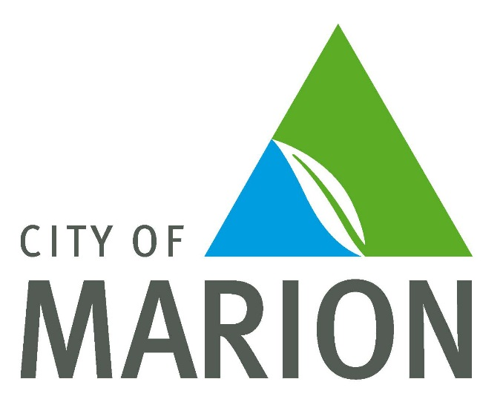

Reserve Street Reserve Evaluation
Community Feedback Report

March 2017

Reserve Street Reserve Evaluation
Community Engagement Summary
March 2017

Following the development of the Dog Park at Reserve Street Reserve, the City of Marion recently sought the community’s feedback about the development and the placement of a toilet at the reserve.

The purpose of the engagement was to inform the community of the project milestones so far at Reserve Street Reserve.

The survey was made available on line at www.makingmarion.com.au/reserve-street-reserve.

The survey was distributed in the following ways
- A hard copy of the survey and reply paid envelope was sent to 409 households within a 400m radius of the reserve
- Social media posts were placed on the City of Marion Facebook page
- Signs were placed at the reserve
- A parks and playgrounds newsletter was sent to a database of 432

The survey was open for 3 weeks – 30th January 2017 - 20th February 2017

We had a total of 84 people complete the survey. 49 surveys were returned via hard copy with the others completed on line.
A full summary of all responses to each question is provided within this report
Overall the development of the Reserve Street Reserve Dog Park has had a positive impact on the community and responses were constructive.
There were some key themes that emerged throughout the consultation and evaluation and these can be taken on board for this and new dog park developments.
Overall summary of key themes received
- The majority of survey respondents (84.7%) agree or strongly agree with the proposed placement of the toilet.
- The survey indicates that users of the dog park are local as well as regional, however, most users (47 respondents) walk to the dog park.
- 30% of visitors use the dog park at least twice a week
- Survey respondents indicated a spread of visiting times over the day.
- 36 respondents stay 1 hour at the dog park
- The majority of respondents (51%) do not use the playground adjacent to the dog park
- Parking concerns are high (25%) with not enough parking and inconsistent opening and closing of Reserve Street Car Park high priorities.
- The majority of dog park users (65%) enter via entry 1 off Adams Road.
- Most respondents (84.5%) agree or strongly agree that the dog park has had a positive influence on the local community.
- More shelter and seating is considered important by respondents with 27 comments noted.
- Litter concerns and the emptying of bins is a worry to residents with over 20 comments received.
- Several respondents raised the issue of creating a small dog park within the boundary to separate large and small dogs.
Some highly critical responses have been received. The majority of these 5/6 are from residents adjoining the park.

Public Toilet Feedback
Respondents were asked to indicate their agreement for the toilet placement as indicated.
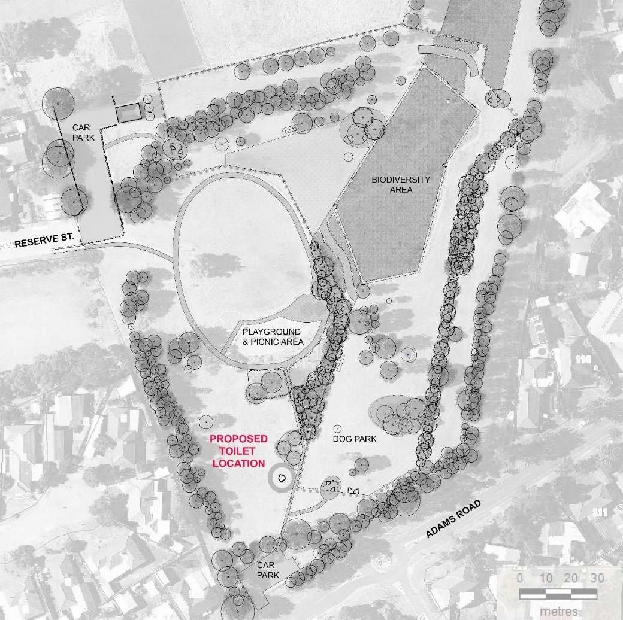

The majority of respondents (84.7%) agreed or strongly agreed with the toilet placement
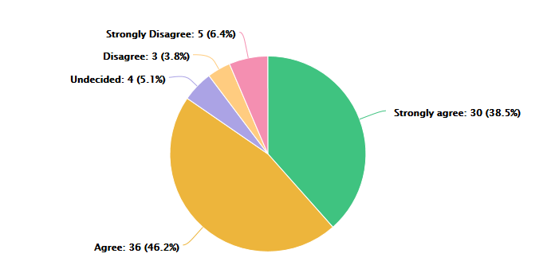

One respondent lived directly behind the proposed placement of the toilet and is opposed to the development.

There were suggestions that the toilet placement would be better suited to the Reserve Street entrance and also responses requesting it not to be places near the Reserve Street entrance. However, there are no services available at this location and costs and time for construction make this location prohibitive. Survey respondents should be well informed that the toilet will be opened and closed at set times and will be cleaned regularly, therefore increased vandalism and negative behavior should not be increased with a toilet.

Comments related to the toilet placement are as follows:
- Fantastic location
- "Toilet is well placed as it is close to playground and Entrance 1 of Dog Park. To place it anywhere else in what would be seen as more secluded areas would make it risky for potential undesirable behaviour.
- Please do not place toilet near Reserve Street entrance."
- The toilet if there is going to be one which I still believe is a bad idea but it should go up near entry 2 as that's where the bigger carpark is and more people come and go from there, having it where proposed is in the middle of nowhere and again blocks off the children's play area, kids need to then walk past a public toilet to get to the playground. god knows what's going to happen at that toilet or near the toilet at night time. we have already on a number of occasions found dirty condoms on and around the playground since the dog park has been there, putting a toilet block on the pathway to the playground is not acceptable
- The proposed site is just far enough from the road to discourage use by passing truck drivers, unlike Onkaparinga's Minkarra toilet block. This is adjacent to Manning Road and too often drivers leave their vehicles on Manning Rd, thereby blocking the sight lines for others leaving the adjacent car park.
- The toilet should be located closer to the larger size car park
- Needs to be clearly visible from Adams Road.
- maybe slightly closer to the playground area, for parents with multiple children and watch others on the playground whilst toileting one
- Maybe more beneficial closer to playground area, as it appears close to the car park and road.
- It should be moved over to the other entrance near the Reserve St. I do not wish to look at a toilet block directly behind my house.
- Too close to houses. Was not consulted about dog park. To me it doesn't seem to get that much use. Feel sorry for people near it. Barely see the playground used. You took away playground equipment from other parks.
- Much needed to complete the reserve.
- We live close to the dog park which you gave us without taking consideration to increase traffic, not enough parking etc. etc.
- Only use the playground occasionally with grandchildren.
- Not needed - no toilet.
- I don't use the dog park as I am not a dog owner however I use the park with my toddler and a parent room would be more suited for us.
- We have been waiting a long time for this.
- It simply does not bother me as I will never use it.
- Concerns with users of the dog park not adequately supervising their dogs whilst using the toilet facilities. Concerns with increased drug use/teenagers/loitering/graffiti in the area.
- If you have people in the park they need a toilet.
- I think that the toilets would be more appropriate near the playground and picnic area for children playing in the playground area.
- I agree that it is probably the best spot to put the toilet, but it is a bit of a walk from Reserve Street and Rix Court.
- Great idea especially for those with kids and grandkids. Love what you have done.
- Just wish that you had sectioned off an area for small dogs only. We can't take our small dog there as bigger dogs hassle her constantly. Very sad we still have to travel to Richmond and North Adelaide to visit small dog parks when we live at Sheidow Park.
- Great idea and great edition to this fabulous space
- Great idea
- AS long as locked at night and regularly cleaned
- Doorway should be turned towards Adams Road as marked

Summary of feedback received
Q1. Approximately how far do you live from the dog park?

0 - 100m | 13
100 - 200m | 6
200 - 300m | 7
300 - 500m | 16
500 - 1000m | 12
>1000m | 27

It is interesting to note that the majority of respondents live more than 500m from the dog park. The dog park attracts users from across the City of Marion and other councils.

Q2. How do you get to the dog park?

walk | 47
car | 32
other | 7

Other responses include bicycle.

Q3. How often do you visit the dog park?

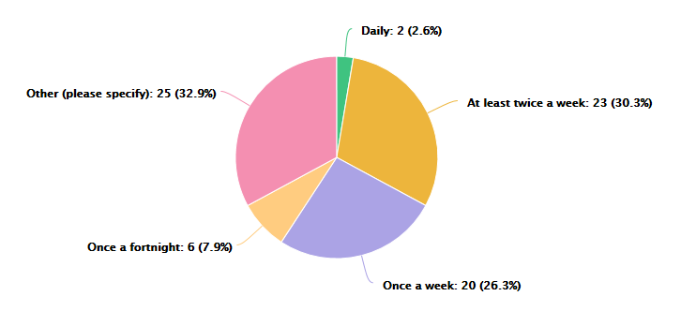
Comments received included
- Every month or so.
- Refuse to go
- We stopped going due to far too many big dogs
- Don't own a dog.
- Never
- Every 2 days
- Never
- Once a month.
- When needed.
- Never
- Used to walk through the park. Cant now.
- I never as I do not need it
- Occasionally.
- we dont
- We own no dogs. Daughter has one comes once a fortnight to use it.
- If large dogs in park I do not enter as I have a small poodle.
- not anymore
- Never
- rarely to never.
- Once a month
- Once a month
- Once a month.
- When time permits
- I don't have a dog, so I don't visit the dog park very often, maybe on average once a year.
- We can't anymore as big dogs pick on our little dog :( otherwise it would have been daily.
- Sometimes up to 4 times a week

Q4. What are the typical times that you visit the dog park?

Early morning | 14
Afternoon | 12
Late morning | 19
Evening | 16
Other | 12

Comments for other include:
- Different times
- It varies. Morning on the weekend or evenings during the week
- comment
- Don't own a dog.
- Anytime of the day
- never
- Our dog likes to exercise in the morning but we can't visit as bigger dogs pick on her.
- This depends on the weather as well

Q5. On average, how long do you spend at the dog park?

½ hour | 24
1 hour | 36
1 ½ hours | 4
2 hours | 1
Other | 7

Comments for other include:
- I don't spend any time at the dog park, but used to spend hours at the playground that has since stopped
- Don't own a dog.
- I do not use the dog park but use the playground and a walk
- 24/7 - I live next to it.
- When we visited we had to leave after about 15 minutes as big dogs hassles our little dog.
- Up to an hour depending if there are other dogs to interact with

Q6. Do you use the playground adjacent to the dog park?
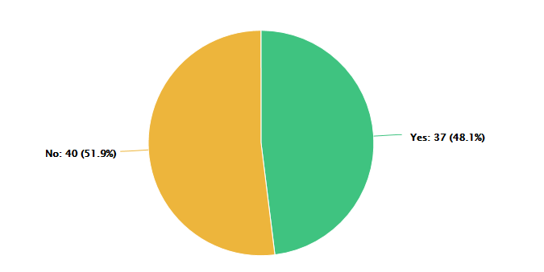

Q7. Have you experienced or identified any issues following the completion of the development?

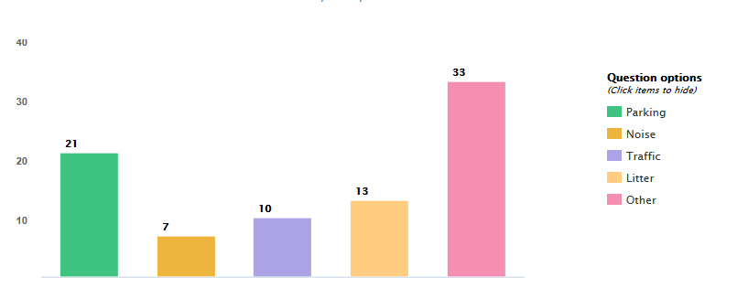
Parking Concerns include:

- The car park on Adams Rd is pretty tight, have recently started parking at reserve st which is much better.
- "Parking- As the only residents on Reserve Street we have had numerous issues with cars parking and spilling onto Reserve Street during peak times (evenings and weekends) when the Reserve Street Reserve gates (Carpark 2) have not been unlocked at the specified times.
- So many cars come and go on Adams Road
- On many occasions the chain has blocked access to the large car park in Reserve Street although I have never arrived earlier than 8.40am. At 84 yrs of age, I find exiting the car park in Adams Rd somewhat difficult owing to limited space to reverse out.
- Car park on Adams road end most times is nowhere big enough and needs to be at least double.
- More parking would help.
- many cars are having to park along Adams Road, as carpark is often full.
- In the hot weather I go earlier to park and on my earlier visits the Reserve Street car park was chained and padlocked. That however, seems to been rectified.
- not enough car parking adjacent for volume of people
- not enough car parking
- Not enough car parking - many parking poorly. Use of street parking and dogs running around.
- It is obvious that some people have no idea how to park.
- Can't park in my street.
- The Adams Road car park is too small and not easy to enter & exit.
- Perhaps advising a larger parking area is available at Reserve Street vs Adams Road.
- The carpark space on Adams rd. can get tight.

Noise concerns include:
- "Noise- Due to Carpark 2 not being locked on numerous occasions in the evenings (especially on weekends) we have heard people doing burn outs and using the area as a meeting place at night time which is especially unsettling as the car park is directly behind our house
- All day you hear dogs barking, it has ruined the serenity that you should be able to get in your own home
- Doesn't affect us.
- Increase noise, dog barking, car engines.
- Live next to it.
- My house's back fence is along the park towards the end of Tyson Avenue. Although it is reasonably far away from the dog park part of the reserve, my neighbour's dog doesn't get walked. If he hears dogs in the park, he will sometimes carry on as he wants to be in the park as well. The issue wasn't as bad before the dog park was installed, but it is now as a lot more dogs are visiting the park.

Traffic concerns include:
- "Traffic- Cars continually drive past our house into Car Park 2 during peak times. Sometimes very fast. Very unsettling especially as we have young children and it’s only a short street.
- way more vehicles are now on the street and use our driveways to turn around. this is unacceptable and I will be blocking it
- A lot a gravel is dragged out on to Adams Road by vehicle exiting the car park. This makes that section of Adams Road very dangerous for motorbike and bicycle riders.
- Parking on roadway, sometimes both side of the road
- Some poorly controlled dogs near Adams Road.
- Additional noise.
- Gravel from Adams Road Park over Adams Road

Litter concerns include:
- See the occasional piece of rubbish on the ground
- there have been so many dirty condoms and food wrappers found over in the park, but let’s remember that all that litter then blows into my carport when its windy!! I shouldn't have to clean up other people’s rubbish so feel free to offer a solution there otherwise ill just be taking it back over and dumping it in the park
- There are limited bins for use within the area
- People not picking up their dog's poop
- people aren't picking up their pets poops
- Increase of litter blowing onto our fence, not a lot.
- Needs to be more rubbish bins because of the park size at least 4-6 bins.
- Not much, just now and then.
- Rubbish bins aren’t collected often enough, most weeks are over flowing
- Increased littering wind blows litter in my front yard.
- Poo bags in my yard/poo on my front garden.
- Bins are always full; people are also not picking up their dogs poo. People are using bins that don't visit dog park to dump hard waste in.
- The bins are not emptied enough and smell really bad of dog poo.
- Dumped alongside bin (domestic)

Other concerns include:
- Mud when it rains on new turf.
- The bags have been out a couple of times for more than a week.
- Other- Carpark 2 Gate is not locked and unlocked at the specified times. There seems to be inconsistencies in this process. It’s quite unsettling to have cars driving and parking in the carpark at night when it should be locked........then it’s quite stressful to see your small street (Reserve Street) jam packed full of parked cars because Carpark 2 Gate has not been unlocked when it’s supposed to be during the day time.
- bins need to be empty more often. one has not been emptied since dog park was opened and it is disgusting. (entry three )
- you have completely destroyed the family neighbourhood and the playground for kids to play on.
- I have a small dog and often the park is full of large dogs and as my dog is a puppy they can be rough. It would be good to have an area within the park sectioned off for puppies and smaller dogs as I've observed little dogs getting chased by larger dogs on several occasions.
- Car dumped in Reserve street car park for some weeks.
- Playground is too small, needs more equipment. Flying fox or bigger slide for example.
- Sometimes no bags available.
- Unturfed area needs weed control especially grass seeds.
- People taking their dog off the lead before entering the dog park. People having their dog off the lead and not using the dog park. Not enough lighting at the dog park/playground at night so teenagers use this to "hang around" at night and let off fireworks. Need more lighting to deter this.
- Looks on gates need to be better quality entry 1 gate locks need to be replaced.
- Increase of dog droppings around the area. eg. footpaths near playground.
- Many people take their dogs off the leads before entering the enclosed dog area, meaning many dogs often run into the children's playground, which poses a safety risk to children!
- Often find the bag dispensers empty.
- Dog owners need to be more diligent re: picking up droppings. Maybe more bags.
- Basketball play surface hollows create large puddles that makes it unusable after even a light shower.
- I have found that graffiti around the bus stops (52) has reduced quite a lot use to be cleaning it off once a week.
- Dog faeces ie. place hand shovel on hook near bins.
- Dogs go everywhere. Dog park too close to play area
- Not enough seating.
- Stress from the dog park and lack of noise constraints as requested to council.
- No shelter provided within the dog park itself.
- We wished there was an area set aside for small dogs only. We can't enjoy the park as bigger dogs pick on our little dog. She enjoys playing with dogs her own size.
- The dog poos bags are not always replaced quick enough and the bins are not emptied quick enough sometimes.
- People let their dogs run into the children's play equipment. HUGE SAFETY HAZARD
- When busy the open space is not enough
- Dog litter bags dispenses empty. Bins need emptying more often – gets pongy

Q8. Are the amenities provided at the dog park sufficient?
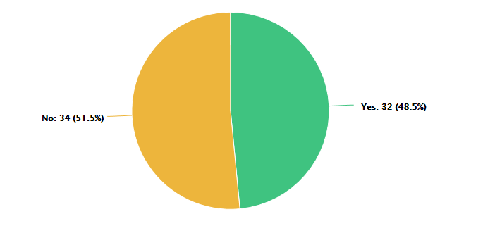
Comments received included

- a shelter similar to the one at Minkara dog park on Manning Road would be handy
- There could be a couple of extra seats around where the nice lawn is.
- need more shaded areas. and more seating.
- Some shade over the bench seats would be nice or more seating under the trees.
- We need some basic cover from the rain and at least two more benches in the upper park, one being in the shade!
- Toilet will be handy and perhaps a little more seating
- There should be more agility items for dogs
- Advising people to grab a poo bag as they enter the area may be a good idea.
- Poo bags often run out
- TOILETS
- toilet would be very beneficial and seating under the shade inside the dog park please
- Could do with large undercover seating areas.
- Better when toilets available. Lovely area.
- Sheltered area required preferably over one or both of the seats.
- Need regular checking of plastic dog bags. (Container is often empty).
- It needs a toilet and a fence around the children's area to stop dogs running into the playground.
- more seats in the shade would be great, and toilet but that's going in anyway
- There are some older people who bring their dogs. Although there are benches they could be in more shade and or have a rain shelter . Something to think about for future development.
- Could use more shaded seating space both inside the dog areas and by the playground
- need the new toilets
- No need anymore
- But would be good to have more toddler play equipment and playground and reliable BBQ's.
- 1). Second covered park bench and table next to BBQ would help more family use of this much improved reserve and community friendly area. 2). Toilet facilities also needed (as planned).
- More seating needed at playground
- More shading and seating in the shade.
- Separate areas for large and small dogs
- A bit more covered shelter would be nice - shelter from rain/ heat
- Needs shade and children’s playground.
- More dog bags, more seats under trees for shade on warm days
- More dog bags.
- no toilets.
- Shelter is needed for warmer days or a sudden shower of rain, maybe over the two bench seats.
- Toilets are a great idea.
- Please put in a small dogs only section, like the one at Richmond and North Adelaide.
- There was nothing before so this is great. There can always be extra.
- Most times I visit there are no poo bags (even though I bring my own)
- No toilet
- Need more shade areas and either bark chips or turf. Lots of grass seeds this spring which is dangerous for dogs.
- Separate area for small dogs. Walking path for use with walking frames etc

Q9. Is the maintenance carried out at the dog park sufficient?
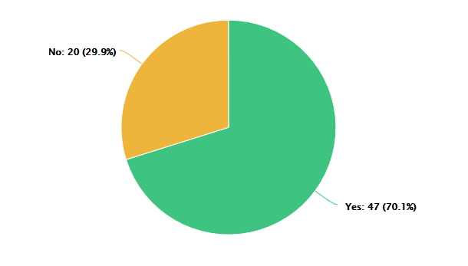
Comments include:
- Could possibly do with more shade or a small shelter
- See above regarding locking and unlocking of Carpark 2 Gate....garden/ lawn maintenance is fantastic however!
- more poo bags are needed
- Grass seeds are a problem
- Our house property borders fence line. Will Council kill weeds that grow between their new black chain wire fence and the existing chain wire fence?
- it appears that all who use the park are doing the correct thing in the way of cleaning after their dogs.
- Bins full and run out of bags. I provide my own but when no bags people just leave excrement instead of having a bag on hand.
- Grass seeds in unturfed area makes park unusable for many in summer. Very expensive vet visit for removal of grass seeds.
- Dry grass which is a fire hazard.
- Rubbish bins for dog poo bags to be emptied more often especially the one at entry 3.
- for a number of weeks the latches that keep the gates start were broken at entry 1.
- Bag dispensers empty most often, but grass and playground area well maintained
- Possibly mowing of the grass on a more regular basis
- need to clean the dog...
- Needs a bit more upkeep.
- 1). Basketball play surface unusable after small shower, due to large puddles under and around ring area. 2). Better maintained green grass areas please.
- not sure
- Bio-diversity area is full of weeds & looks very over-grown. Fire hazard& snakes in area. I feel money would have been better spent if area could be used for small dogs. It is of no use all these many species of plants & signs explaining what they are.
- The Adams Rd gate was broken for 1 - 2 weeks, looked like someone had done a temp fix to keep it safely closed.
- Adams Rd gate was broken for 1 - 2 weeks & had been temp repaired by someone
- Nicer lawned area would be appreciated all over.
- n/a
- Smell the bins/dry, cracked earth.
- Bag replacement and bins emptied more regularly, gate locks are not strong enough
- Gate broken often.
- More regular bin collection and bag disposal refilling
- Lawns are overgrown near fence of dog park, bins need emptying more often

Q.10 Which entry and exit point do you usually use?

Entry 1 | 46
Entry 2 | 23
Entry 3 | 2

Q.11 The development has had a positive impact on the local community?
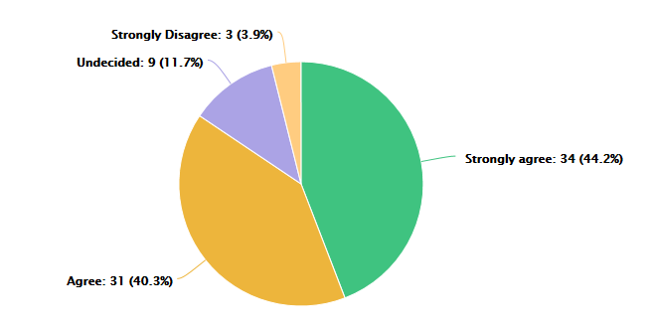
Comments include:
- Fantastic place for dogs to socialise and gain new skills
- Its a great facility and About time some money was spent "up the hill"
- The impact it has had on us is good and bad. Wonderful facility but we were only consulted only 2 weeks prior to works commencing that dog park had increased from a 4000sqm dog park to a 10000sqm dog park & that carpark would be reopened behind our house.
- Large dog breeds are loving it
- Amazing to have a place for pets and owners to socialise!
- Concern regarding weeds between our fence and black chain wire fence at border, highlighted on enclosed map.
- Aware many come from attending previous dog pars as larger.
- Have met many people through common interests and love interaction with other owners.
- It has brought more people to Trott Park.
- possibly not to immediate neighbours but people travel quite some way to bring their dog off lead here
- I'm not a local but I have heard positive comments.
- The development had a negative impact to the immediate community.
- Well done to transform this previously wasted space to become an enjoyable shared area for all to enjoy, socialise and improve health/fitness for a better community.
- Appears to be well used.
- Doesn’t help us when our kids are scared of dogs and we used to use the park.
- would not know.
- Neighbours and friends not happy. Residents next to park distressed out of lack of council actions.
- It is amazing what a simple fence has done to the park. Before, hardly anyone would visit the park but now it seems like every day there are a lot of people making use of the park with their dogs.
- Have had lots of comments about it would be good if there was a small dogs only section, other people seem to have the same issue we do.

Q12. Do you have any other comments or suggestions regarding this dog park or future dog parks in the City of Marion?

Comments include:
- Great size, enjoy the grass rather than wood chips
- More than happy with hit it thanks
- "Direct consultation with the immediate residents in the area who will be directly impacted by new developments would be an appropriate and considerate start.
- A phone call, email or letter direct to the resident directly impacted is much more appropriate as opposed to a generic flyer put in the post showing new dog park plans that have been already approved and only 2 weeks’ notice for works to commence!
- As immediate residents we had no time to view our concerns and it was too late. Plans had been approved. We didn't voice our concerns with the initial plan showing a 4000sqm dog park because we were happy with it. Imagine our surprise several months later with a new flyer in the mail showing a 10000sqm dog park and a car park behind our house! And it had been already approved for works to go ahead.
- The re-opening of the Carpark on Reserve Street has had a stressful impact on us unfortunately but I think irregularities in the locking and unlocking of the gate has a lot to do with this."
- Move to toilet to Entry 2. away from the kids play area and give them a free walk to the playground, they already have to deal with dogs bowling them over that aren't on their leads!!
- Considering the park is so big maybe a fenced area for small dogs.
- "Like several other regular users, I live in Happy Valley/Aberfoyle Park area & use this and Minkarra dog park. For energetic dogs like mine, the wide grassy area is excellent & I commend Marion Council for this development. It is ideal for ball throwing, the atmosphere amongst dog owners is good but it just needs some shelter from sun & rain, plus more benches.
- "Absolutely need an area off-limits to large dogs.
- Not apart from creating a section for small dogs and puppies in only
- "More shade needed over the seating and shelter for rainy days
- Often find the Reserve Rd carpark is closed (chain hasn't been unlocked) "
- The biodiversity area is really not in a good position, it should be ONLY outside the dog park, dog balls get lost, long grass is a hazard due to snakes near dogs, it really is silly to have an area within the run space fenced off
- "Not to have the biodiversity era inside the park. It is very inconvenient loosing toys in the area and a safety concern regarding the long grass and snakes/lizards in summer!
- A dog park in Hallett Cove would be amazing! thank you!"
- Many more people walking their dogs past my home.
- For people that use the park in winter or on wet days there should be 3-4 under cover seating areas and at least 3-4 times the size larger (bus stop shelters).
- We need tennis courts.
- Some people do let their dogs dig, especially lawned area and leave the holes. This concerns me as a dog may break or damage legs. Have filled them in several times only to find dug up again? signage alluding to possible accidents.
- Grass seeds are an issue. Hope all areas nicely turfed if financially possible in future.
- Need a small and large dog area.
- No more dog parks.
- If possible, dog parks need to be bigger (about the size of the dog park at Glengowrie) so the dogs can run freely without other dogs standing over the top of them.
- Not so much the dog park at the playground there is insufficient shade over the playground itself. I believe the soil shade up above the play equipment would increase the use over summer.
- For future dog parks, please consider a greater distance between children's playgrounds and dog parks or another fence around the playground so dogs cannot run into the kids area, which often occurs at this site.
- "1. springs on the entry gates to make sure they close behind you (less chance of dogs escaping the double gate)
- 2. seats and shade on the playground side
- "This dog park is nice and big the dogs love to run.
- The dog park was placed in the wrong end of the carpark as people with kids cannot use the playground amenities. The council gave more importance to the dogs over the kids.
- Create wheelchair and mobility access paths in and around garden and play areas for use and enjoyment by elderly and handicapped community members.
- Need to ensure adequate (preferably off road) parking is provided at future dog parks. Perhaps some signposts to the larger back car park would be handy - if not already installed.
- Make a separate area for small dogs.
- Have more separation between playground and park.
- No
- Love this dog park - everyone who is there seems to love it as well.
- To make them larger not so confined and more lawned areas. Obstacles for dogs would be a though.
- no
- No toilet block next to our house but that will be ignored just like our request to locate the dog park somewhere else away from housing. I go to the beach and I am inundated with dogs off their leads. Why do we have to have dog parks when they're all at the beach. Can't get away from them!!
- We no longer have a dog but walk pass the park most days and see the park being used. The dogs are very excited when they get out of the car and are really pulling on their leads to get in the gate. We have seen not trouble with the dog park. We do take our grandchildren to the playground and the toilet would let us stay longer.
- Would like a separate area for small dogs puppies and dogs on leads. Also making sure dogs are safe when in there. Haven't had any problems but it would be a good idea to have a special area for guide and disability dogs to have a safe run with their clients. Just a thought, I am currently educating a guide dog puppy and think this would be a good idea as there are many visually impaired people in the area who have guide dogs. Would like more benches under the trees for shade on warm days to sit.
- I would like to see some permanent netted soccer goals put in at the park.
- Having lived in the area for over 35 years, this has been a good initiative, however we believe that some form of additional shelters should be made available. In need maybe additional security lighting at night within the dog park itself.
- I think they are a good idea for people who are a bit worried about taking their dogs off the leash. If dogs are well trained, they don't necessarily need to be confined to being in an enclosed area, but it gives owners confidence that their dog won't run off.
- Please consider sectioning off an area for small dogs only. They enjoy a run and play off lead just as much as big dogs but some owners don't have a lot of control over large excitable dogs so we can't enjoy the park and still have to travel to Richmond and North Adelaide small dog parks.
- A shallow dog pool for summer. Better gate locks, not so flimsy. Smaller extra fenced off area for timid/small dogs or young puppies.
- "Please do not separate the dog areas in this park into small and big dogs! Discriminatory against big dogs like mine that are social with all dogs.
- Future dog parks - more of them when you can please!"
- DOGS RUN ONTO THE CHILDREN'S PLAYGROUND. THIS IS NOT OK!
- People need signage to educate them about dog behaviour. Some very disruptive dogs use the park and the owners just laugh even though their dogs are getting in other dogs space trying to start fights or being plain aggressive due to pack mentality (especially some huskies in early morning). Needs better monitoring if possible.
- The dog park is good, although would be good to have more open space with less trees to crash in to
- If possible a separate area just for dogs on leads would be great. Not all dogs are under effective control and a separate area to prevent out of control dogs running up to dogs on leads would be great.

Facebook Feedback
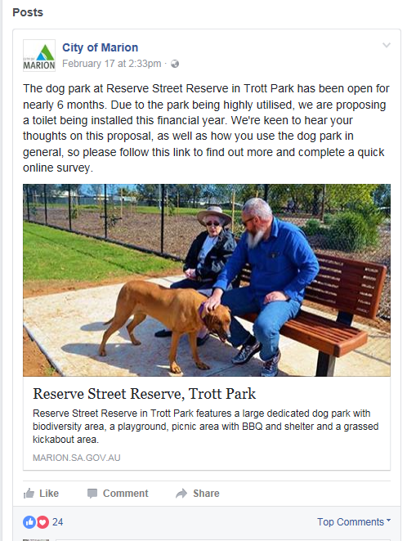
Social media posts called for people to comment on the reserve street reserve development.

Comments Included:
- A toilet over near the lions shed would be a good idea.
- This dog park gets too many prickles not good for our pups

We thank the community who took the time to provide their feedback and participate in the engagement process.

